Module 1 – Overview of IT Industry
1.What is a Program?
Program –it is a set of instruction.
LAB EXERCISE:
In c language:
#include<stdio.h>
#include<conio.h>
void main()
{
printf("Hello");

getch();
}
In python language:
print("Hello World")

Here is the Comparison of the structure and syntax: C language requires header files and a main() function. It uses semicolons and braces, making the syntax strict and lengthy.
Python language does not need header files or a main() function. It uses indentation instead of braces and has simple, readable syntax.

2.THEORY EXERCISE:
1.Explain in your own words what a program is and how it functions.
- A program functions by taking input, processing it according to the given instructions, and then producing an output. When a program is executed, the computer reads the instructions step by step and follows them in order to complete the task.

2. What is Programming?
- Programming is to create a program.

3.THEORY EXERCISE:
1.What are the key steps involved in the programming process?
- The programming process involves understanding the problem, designing a solution using an algorithm or flowchart, writing the code in a programming language, testing and debugging the program, and finally executing and maintaining it to ensure it works correctly.
2. Types of Programming Languages.
- c, c++, prolog, python,

4.THEORY EXERCISE:
- What are the main differences between high-level and low-level programming languages?
- High-level programming languages: They are easy to read and write, closer to human language, and machine-independent (e.g., Python, Java).

- Low-level programming languages: They are closer to hardware, difficult to understand, machine-dependent, and give more control over the system (e.g., Assembly, Machine language).

- World Wide Web & How Internet Works?
- The World Wide Web works by using web browsers, web servers, and HTTP/HTTPS. When a user enters a website address, the browser sends a request to a web server. The server responds by sending web pages, which are then displayed in the browser.
- The Internet works as a global network of connected computers. Data is broken into small packets and sent through routers and servers using communication protocols like TCP/IP, allowing information to travel from one computer to another worldwide.

5. THEORY EXERCISE:
1. Research and create a diagram of how data is transmitted from a client to a server over the internet.
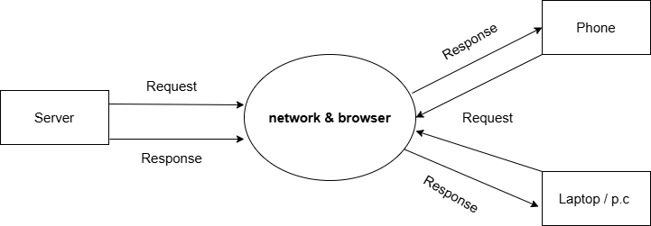

6. THEORY EXERCISE:
1. Describe the roles of the client and server in web communication.
- Client:
The client is the user’s device (computer or mobile) that requests information from the web. It uses a web browser to send requests (HTTP/HTTPS) to a server and displays the received response, such as web pages, images, or data.
- Server:
The server is a powerful computer that stores websites and data. It receives requests from clients, processes them, and sends back the requested information to the client.
2. Network Layers on Client and Server
- The network layer on both the client and server is responsible for delivering data packets across the internet. It handles logical addressing (IP addresses), routing, and choosing the best path for data to travel. When a client sends a request, the network layer routes it through the internet to the server, and the server’s network layer sends the response back to the client.

LAB EXERCISE:

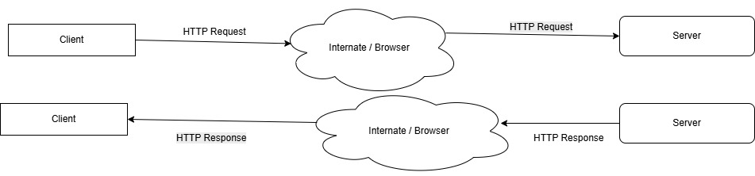

7. THEORY EXERCISE:
1. Explain the function of the TCP/IP model and its layers.
- The TCP/IP model helps data travel from one device to another by breaking it into layers, where each layer performs a specific task to ensure safe and accurate communication.

8. THEORY EXERCISE:

1. Explain Client–Server Communication
Client–server communication is a process where the client sends a request to the server, and the server processes it and sends back the required data.

2. Types of Internet Connections
- Dial-up
- DSL
- Broadband
- Fiber-Optic
- Satellite
- Mobile Data (4G/5G)

LAB EXERCISE:
Research different types of internet connections (e.g., broadband, fiber, satellite) and list their pros and cons.

Different Types of Internet Connections
Broadband
• Fast internet connection
• Used in homes and offices
Fiber-Optic
• Very high-speed internet
• Uses fiber cables
Satellite
• Works in remote areas
• Uses satellites

9. THEORY EXERCISE:

1. How does Broadband differ from Fiber-Optic Internet?
Broadband uses copper cables and provides moderate speed, while fiber-optic uses fiber cables and provides very high speed.

Protocols
Protocols are rules used for communication between devices on a network.
Examples: HTTP, HTTPS, FTP, TCP, UDP, IP
LAB EXERCISE:
Simulate HTTP and FTP requests using command line tools (e.g., curl).
HTTP request:
curl http://example.com – gets a web page
FTP request:
curl ftp://ftp.example.com – accesses FTP files

10. THEORY EXERCISE:
1. What are the differences between HTTP and HTTPS protocols? Application Security
- HTTP is not secure and does not encrypt data.
- HTTPS is secure and encrypts data using SSL/TLS.
- HTTP is faster but unsafe.
- HTTPS is slightly slower but safe for data transfer.

Application Security
Application security means protecting software applications from attacks by using security techniques like authentication, encryption, and access control.

LAB EXERCISE:
Identify and explain three common application security vulnerabilities. Suggest possible solutions.

Three Common Application Security Vulnerabilities & Solutions
- SQL Injection
Problem: Attackers insert malicious SQL code.
Solution: Use input validation and prepared statements.
- Weak Passwords
Problem: Easy passwords can be hacked.
Solution: Use strong passwords and authentication.
- Cross-Site Scripting (XSS)
Problem: Malicious scripts run in the browser.
Solution: Validate and sanitize user input.

11. THEORY EXERCISE:
1. What is the role of encryption in securing applications? Software Applications and Its Types
Encryption protects application data by converting it into unreadable code so only authorized users can access it. It helps secure sensitive information during storage and transmission. Even if attackers intercept the data, they cannot understand it without the correct key.

LAB EXERCISE:
Identify and classify 5 applications you use daily as either systemsoftware or application software.
• System software works in the background and helps the computer run properly.
Example: Windows, Linux
• Application software is used by users to do specific tasks.
Example: MS Word, Chrome

12. THEORY EXERCISE:
1. What is the difference between system software and application software? Software Architecture
System software is the main software that controls and manages the computer hardware. It helps the system start, run smoothly, and supports other software. Examples include Windows, Linux, and macOS.
Application software is designed for users to perform specific tasks such as writing documents, browsing the internet, or chatting. Examples include MS Word, Google Chrome, and WhatsApp.

LAB EXERCISE:
Design a basic three-tier software architecture diagram for a web application
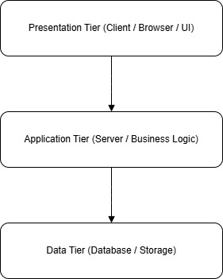

13. THEORY EXERCISE:
1. What is the significance of modularity in software architecture?
Modularity means dividing a software system into smaller independent parts. It makes the system easier to understand, test, maintain, and update. Changes in one module do not affect the entire system, which improves flexibility and reduces errors.

2. Layers in Software Architecture
There are 5 layers in software architecture:
1. Presentation Layer
2. Application Layer
3. Business Layer
4. Persistence Layer
5. Database Layer

LAB EXERCISE:
Create a case study on the functionality of the presentation, business logic, anddataaccess layers of a given software system
Presentation Layer:
Displays product lists, login pages, and shopping cart to users.
Business Logic Layer:
Handles order processing, price calculation, and user authentication.
Data Access Layer:
Stores and retrieves data such as user details, products, and orders from the database.

14. THEORY EXERCISE:
1. Why are layers important in software architecture?
Layers are important because they organize the system into separate parts, making it easier to understand, maintain, and update. They help reduce complexity, improve security, and allow changes in one layer without affecting others.
2.Software Environments?
A software environment is the setup where programs run, including the operating system, software tools, and libraries.It helps programs work correctly and interact with the computer. Examples: Windows, Linux, and Python development environment.
LAB EXERCISE:
Explore different types of software environments (development, testing, production). Set up a basic environment in a virtual machine
- Development Environment
Used by developers to write and test code. It may contain debugging tools and unfinished features.
- Testing Environment
Used to test the application for errors and bugs before release. It checks performance, security, and functionality.
- Production Environment
This is the final live environment where users access the application.

15. THEORY EXERCISE:
1. Explain the importance of a development environment in software production. Source Code
A development environment is important because it provides developers with the tools needed to write, test, and debug source code safely. It helps find errors early, improves code quality, and allows changes without affecting the final product. This environment also supports collaboration and faster development before the software is released to users.

LAB EXERCISE:
Write and upload your first source code file to Github?
Write your first program in a source code file, like hello.c or hello.py. Then, create a repository on GitHub, add your file, commit the changes, and push it to upload your code online. This way, your program is safely stored and can be shared or updated anytime
Example :
https://github.com/mahimasavariya/SE_Workspace.git

16. THEORY EXERCISE:
1. What is the difference between source code and machine code? Github and Introductions
Source code is the set of instructions written by a programmer in a human-readable programming language. Computers cannot directly execute it. Machine code, on the other hand, is the low-level binary code (0s and 1s) that the computer can understand and run directly. Essentially, source code is written by humans, while machine code is understood by computers

LAB EXERCISE:
Create a Github repository and document how to commit and push code changes.
• Log in to GitHub and click New Repository.
• Name your repository and create it.
• On your computer, navigate to your project folder in the terminal.
• Run git init to initialize Git.
• Add your files: git add .
• Commit changes: git commit -m "Initial commit"
• Connect to GitHub: git remote add origin <repository_URL>
• Push changes: git push -u origin main

17. THEORY EXERCISE:
1. Why is version control important in software development?
Version control helps track changes in code over time, allows multiple developers to work together without conflicts, and makes it easy to revert to previous versions if something goes wrong. It ensures better collaboration and safer development.

LAB EXERCISE:
Create a student account on Github and collaborate on a small project with aclassmate.
• Go to GitHub and sign up with your student email.
• Verify your account and set up a profile.
• Create a repository or accept an invitation from your classmate’s repository.
• Work together by making commits, pushing changes, and reviewing each other’s code.

18. THEORY EXERCISE:
1. What are the benefits of using Github for students?
GitHub helps students learn version control, collaborate on projects, maintain a portfolio, and get familiar with real-world software development practices. It also makes sharing code and receiving feedback easier.
2. Types of Software
1. System Software: Helps the computer run, like Windows, Linux, or macOS.
2. Application Software: Programs for tasks, like MS Word, Excel, or web browsers.
3. Programming Software: Tools to write code, like Visual Studio, Eclipse, or Python IDEs.

LAB EXERCISE:
Create a list of software you use regularly and classify them into the followingcategories: system, application, and utility software
1. System Software:
Windows 10 (operating system)
2. Application Software:
Google Chrome (web browser)
MS Word (document editing)
VLC Media Player (video player)
3. Utility Software:
CCleaner (system cleanup)
Windows Defender (antivirus)
WinRAR (file compression

19. THEORY EXERCISE:
1. What are the differences between open-source and proprietary software?
- Open-Source Software: The source code is freely available, can be modified and shared, usually free, and supported by a community.
- Proprietary Software: The source code is closed, cannot be modified, usually paid, and supported officially by the vendor.
- Example: Open-Source → Linux, Firefox | Proprietary → Windows, Adobe Photoshop

2. GIT and GITHUB Training?
- Git: A tool installed on your computer for version control; it tracks changes and manages project history.
- GitHub: An online platform to host Git repositories, share projects, and collaborate with others.
- Basic Workflow:
  - Clone a repository from GitHub.
  - Make changes locally.
  - Add changes: git add .
  - Commit changes: git commit -m "message"
  - Push changes to GitHub: git push origin main

LAB EXERCISE:
Follow a GIT tutorial to practice cloning, branching, and merging repositories
Cloning: Download a copy of a repository from GitHub to your local computer using git clone <repository_URL>.
Branching: Create a new branch to work on features independently using git branch <branch_name> and switch using git checkout <branch_name>.
Merging: Combine changes from one branch into another using git merge <branch_name>.
Practice: Follow a tutorial step by step to clone a repo, create branches, make changes, and merge them back into the main branch.

20. THEORY EXERCISE:
1. How does GIT improve collaboration in a software development team?
Git allows multiple developers to work on the same project simultaneously without overwriting each other’s work.
It tracks all changes, making it easy to review, revert, or merge updates. Branching and merging help organize features and bug fixes separately, improving team workflow and reducing conflicts.

2.Application Software?
Definition: Software designed to help users perform specific tasks, such as writing documents, browsing the internet, or playing media.
Examples: Microsoft Word, Google Chrome, VLC Media Player, Photoshop.
Purpose: Application software focuses on user needs rather than managing hardware or system resources.

LAB EXERCISE:
Write a report on the various types of application software and how they improve productivity.
Application software includes programs like word processors, spreadsheets, and web browsers.
They help users perform tasks faster and more accurately, such as writing documents or analyzing data.
Using these tools improves productivity and efficiency in daily work and learning.

21. THEORY EXERCISE:
1. What is the role of application software in businesses?
Application software helps businesses perform daily operations smoothly, such as managing documents, analyzing data, and communicating with clients. It improves efficiency, reduces errors, and supports decision-making by providing tools for data analysis, project management, and financial tracking. Examples: Accounting software (Tally, QuickBooks), CRM software (Salesforce), Office tools (Word, Excel).
2. Software Development Process?The software development process is a step-by-step method to create software.
It includes planning, designing, coding, testing, and maintaining the software.
Following this process ensures the software is efficient, reliable, and meets user needs.
LAB EXERCISE:
Create a flowchart representing the Software Development Life Cycle (SDLC).

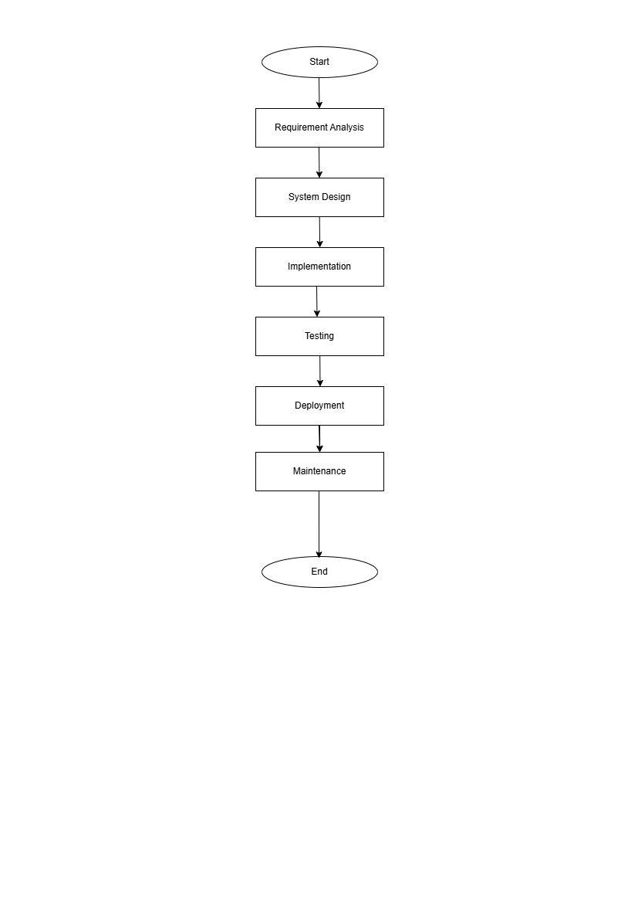

22. THEORY EXERCISE:
1. What are the main stages of the software development process?
There are 6 main stages of the software development process.
1. Requirement Gathering
2. Analysis
3. Designing
4. Implementation
5. Testing
6. Maintenance
2.Software Requirement?
Software requirements are the needs and features that a software must have to work correctly.
They tell developers what the software should do and how it should behave.
Clear requirements help create software that meets user expectations.

LAB EXERCISE:
Write a requirement specification for a simple library management system
1. Purpose:
To manage books, members, and borrowing activities efficiently in a library.
2. Functional Requirements:
Add, update, and delete books.
Register and manage library members.
Issue and return books with dates.
Search for books by title, author, or category.
3. Non-Functional Requirements:
The system should be easy to use.
Data should be stored securely
The system should respond quickly to user actions.
4. Users:
Librarian (admin tasks)
Members (borrow and return books)

23. THEORY EXERCISE:

1. Why is the requirement analysis phase critical in software development?
The requirement analysis phase is critical because it defines what the software should do before coding begins.
It helps developers understand user needs and avoid mistakes later.
Clear requirements save time, effort, and cost, ensuring the final software works correctly for users.

2.Software Analysis?
Software analysis is the process of studying user needs and system requirements before creating software.
It helps understand what the software should do and how it should work.
Good analysis ensures the software is useful, efficient, and meets user expectations.

LAB EXERCISE:
perform a functional analysis for an online shopping system
- User Registration/Login: Users can create accounts and log in.
- Product Browsing/Search: Users can browse categories or search products.
- Product Details & Reviews: View product info, images, and reviews.
- Shopping Cart: Add, remove, or update products; view total cost.
- Checkout & Payment: Select address, choose payment method, confirm order.
- Order Tracking: Track order status and receive notifications.
- Admin Functions: Add/update products, manage orders, and handle queries.
- Security: Protect user data and secure transactions.

23. THEORY EXERCISE:
1. What is the role of software analysis in the development process?
Software analysis helps understand user requirements and what the system must do.
It identifies problems, defines system functions, and sets clear objectives before coding.
Ensures the software meets user needs, reduces errors, and guides design and implementation.
Basically, it lays the foundation for building a reliable and efficient system.

2. System Design
System design is the process of planning how a software system will work and how its parts will interact.
It defines the structure, components, and data flow of the system.
Good system design helps make software organized, efficient, and easy to maintain.

LAB EXERCISE:
Design a basic system architecture for a food delivery app
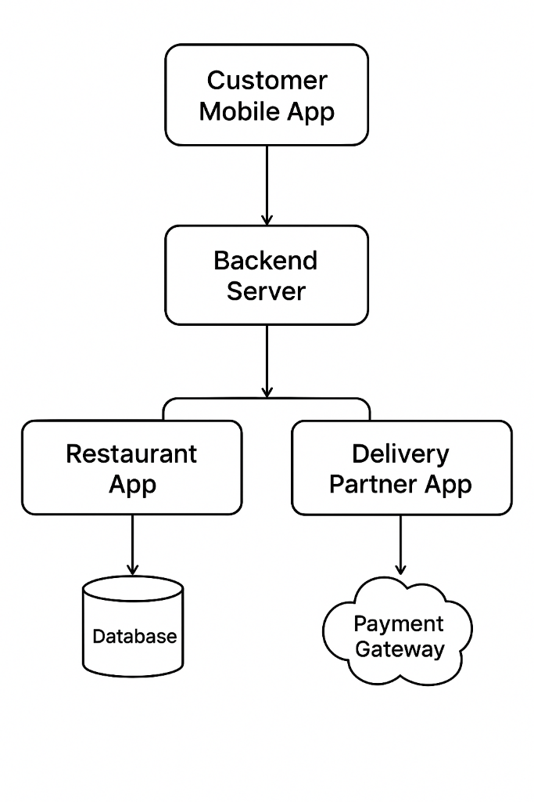

23. THEORY EXERCISE:

1. What are the key elements of system design?
The key elements of system design include architecture, which defines how the system is structured.
It also includes data design and interface design, which show how data is stored and how users interact with the system.
Another important element is component design, which defines how different parts of the system work together.

2. Software Testing?
Software testing is the process of checking a program to find errors before it is released.
It ensures the software works correctly and meets user needs.
Testing helps improve quality, reliability, and user satisfaction.

LAB EXERCISE:
Develop test cases for a simple calculator program
1. Addition Test Case
Input: 5 + 3
Expected Output: 8
2. Subtraction Test Case
Input: 10 – 4
Expected Output: 6
3. Multiplication Test Case
Input: 6 × 2
Expected Output: 12
4. Division Test Case
Input: 20 ÷ 5
Expected Output: 4
5. Division by Zero Test Case
Input: 10 ÷ 0
Expected Output: Error message (cannot divide by zero)
6. Negative Numbers Test Case
Input: –7 + 2
Expected Output: –5
7. Decimal Numbers Test Case
Input: 2.5 × 2
Expected Output: 5.0

23. THEORY EXERCISE:
1.Why is software testing important?
Software testing is important because it helps find and fix errors before users face them.
It ensures the software works properly and meets requirements.
Testing improves quality, safety, and user satisfaction

2. Maintenance?
Software maintenance is the process of updating and improving software after it is released

LAB EXERCISE:
Document a real-world case where a software application required critical maintenance.
A real-world example of critical software maintenance is WhatsApp. At one time, WhatsApp faced security issues where user data could be at risk due to software bugs. To fix this, the developers released urgent updates to improve security, fix bugs, and prevent unauthorized access. Regular maintenance was also required to support new features, improve performance, and ensure compatibility with new mobile operating systems. This case shows that software maintenance is important to keep applications secure, reliable, and up to date for users.

23. THEORY EXERCISE:
1.What types of software maintenance are there?
orrective Maintenance: Fixes bugs and errors found after the software is released.
Adaptive Maintenance: Updates the software to work with new hardware, operating systems, or environments.
Perfective Maintenance: Improves performance, features, or usability based on user feedback.
Preventive Maintenance: Reduces future problems by improving code quality and fixing potential issues early.

2.Development ?
Software development is the process of designing, creating, testing, and maintaining software applications. It includes planning, coding, testing, deployment, and regular updates to meet user needs and improve functionality.

24. THEORY EXERCISE:
1. What are the key differences between web and desktop applications?
Web applications run in a web browser and need an internet connection.
Desktop applications are installed on a computer and can work without the internet.

2. Web Application
A web application is a software program that runs on a web browser and can be accessed through the internet. It does not need to be installed on the device and can be used from anywhere using a browser. Examples include Google Docs, Instagram, and online shopping websites.

25. THEORY EXERCISE:
1. What are the advantages of using web applications over desktop applications?
Web applications can be accessed from anywhere using a browser.
They do not require installation and are easy to update automatically.
They work on multiple devices and operating systems.
Data is stored online, making collaboration and sharing easier.
Maintenance and updates are handled on the server side.

2. Designing
Designing is the stage in software development where the structure and layout of the system are planned. It includes designing the user interface, system architecture, database structure, and overall workflow. Good design helps make the software easy to use, efficient, and scalable before actual coding begins.

26. THEORY EXERCISE:
1. What role does UI/UX design play in application development?
UI/UX design helps make an application easy to use and visually appealing. UI (User Interface) focuses on how the app looks, while UX (User Experience) focuses on how smoothly users can interact with it. Good UI/UX improves user satisfaction, reduces confusion, and increases user engagement.

2. Mobile Application?
A mobile application is a software program designed to run on smartphones and tablets. It helps users perform specific tasks such as communication, shopping, gaming, or learning. Examples include WhatsApp, Instagram, and Google Maps.

27. THEORY EXERCISE:
1. What are the differences between native and hybrid mobile apps?
Native apps are built specifically for one platform like Android or iOS, so they run faster and smoother.
Hybrid apps use web technologies and work on multiple platforms with a single code.
Native apps give better performance, while hybrid apps save time and cost

2. DFD (Data Flow Diagram)?
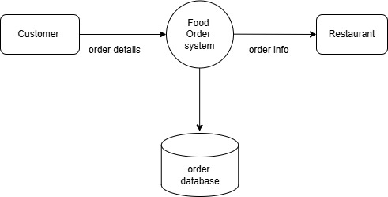

LAB EXERCISE:
Create a DFD for a hospital management system.
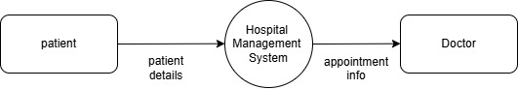

28. THEORY EXERCISE:
1. What is the significance of DFDs in system analysis?
Data Flow Diagrams (DFDs) help in understanding how data moves within a system. They show the flow of information between processes, data stores, and external entities. DFDs make complex systems easier to understand, help in identifying errors early, and improve communication between developers and users during system analysis.
2. Desktop Application?
A desktop application is software that is installed and runs on a personal computer or laptop. It works offline and uses system resources directly. Examples include Microsoft Word, VLC Media Player, and Adobe Photoshop.

LAB EXERCISE:
Build a simple desktop calculator application using a GUI library

29. THEORY EXERCISE:

1. What are the pros and cons of desktop applications compared to web applications?
Pros and Cons mean the advantages and disadvantages of something.
- Pros → Good points or benefits
- Cons → Bad points or drawbacks
Example:
Using a mobile phone
- Pros: Easy communication, quick access to information
- Cons: Battery drains fast, can cause distraction
2. Flow Chart?
A Flowchart is a diagram that shows the steps of a process using symbols and arrows.
It helps visualize how tasks, decisions, and actions are connected.
Flowcharts make it easier to understand, plan, and solve problems.

LAB EXERCISE:
Draw a flowchart representing the logic of a basic online registration system.
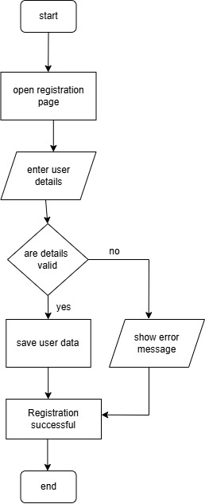

30. THEORY EXERCISE:
1. How do flowcharts help in programming and system design?
Flowcharts help by showing the steps of a program or system visually, making it easier to understand. They also help communicate ideas clearly to others.

